# Naan Mudhalvan

**DIGITAL MARKETING**

**FINAL PROJECT TITLE:**

CREATE A GOOGLE MY BUSINESS PROFILE

**COLLEGE NAME:**

CHENDHURAN COLLEGE OF ENGINEERING AND TECHNOLOGY

**DEPARTMENT:**

MECHANICAL ENGINEERING

**YEAR/SEM:**

FINAL YEAR/ 7TH SEM

**TEAM MEMBERS:**(4 PERSON)

|  |  |  |  |
| --- | --- | --- | --- |
| **S.NO** | **NAME** | **NAAN MUDHALVAN ID** | **REGISTER NUMBER** |
| 1 | V.SUDHARSAN - **(LEDER)** | 0A9C1CB934BB08ABFFC4C744A84CB8C4 | (910320114007) |
| 2 | M.JEGADEESH | FCF482E3BBAD3D9B66F43C 75235856AA | (910320114304) |
| 3 | A.THAVAMANI KANNAN | 979E753CDB221BC82084C997142ED 215 | (910320114311) |
| 4 | S.MOHANASUNDARAM | 107E9265B139FA7B0934E12A3E565CEB | (910320114004) |

YouTube video link

https://youtu.be/BpnIMAsbkA0?feature=shared

PROJECT SCREEN SHOTS:

Search: google my business profile :

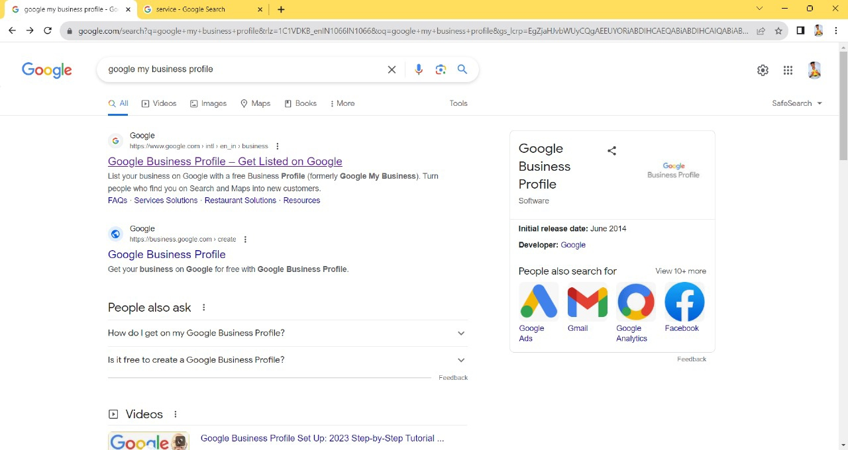

Overview of business profile:

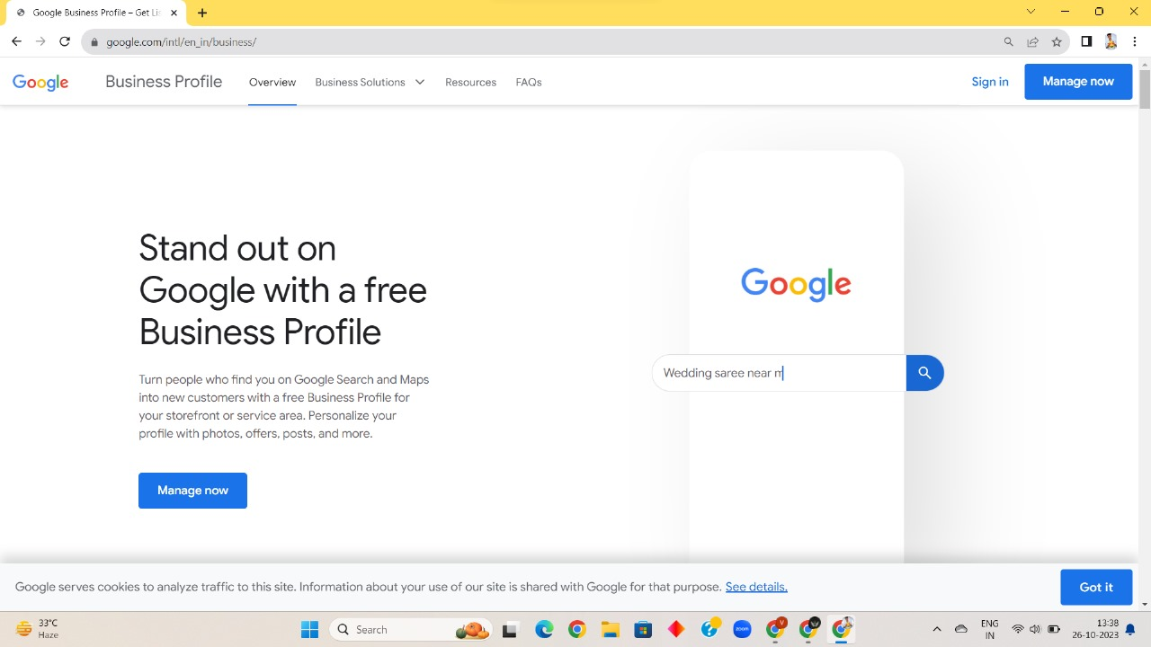

Request access business profile

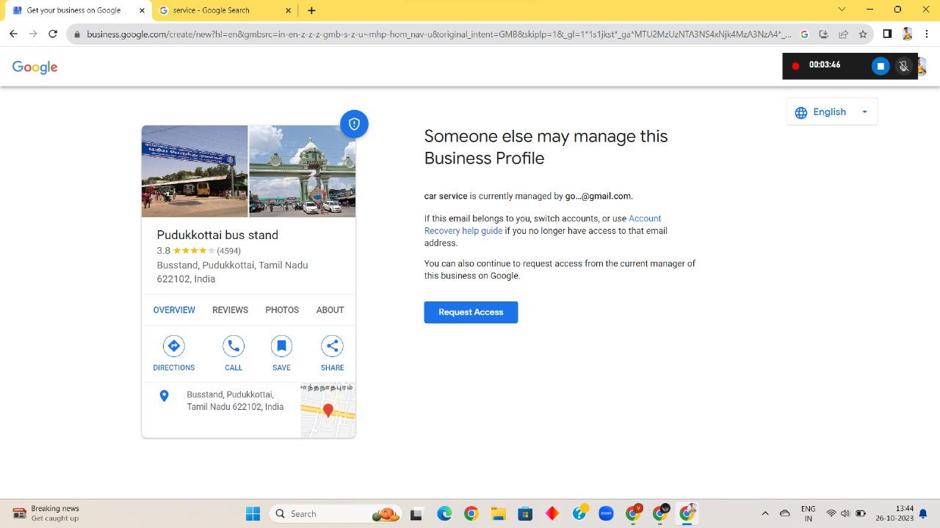

Add photos on business

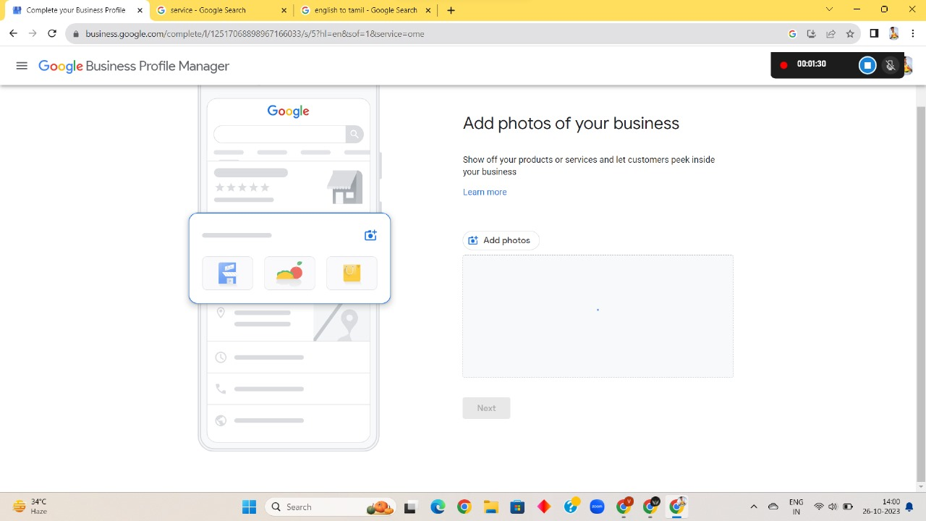

Open my business profile

